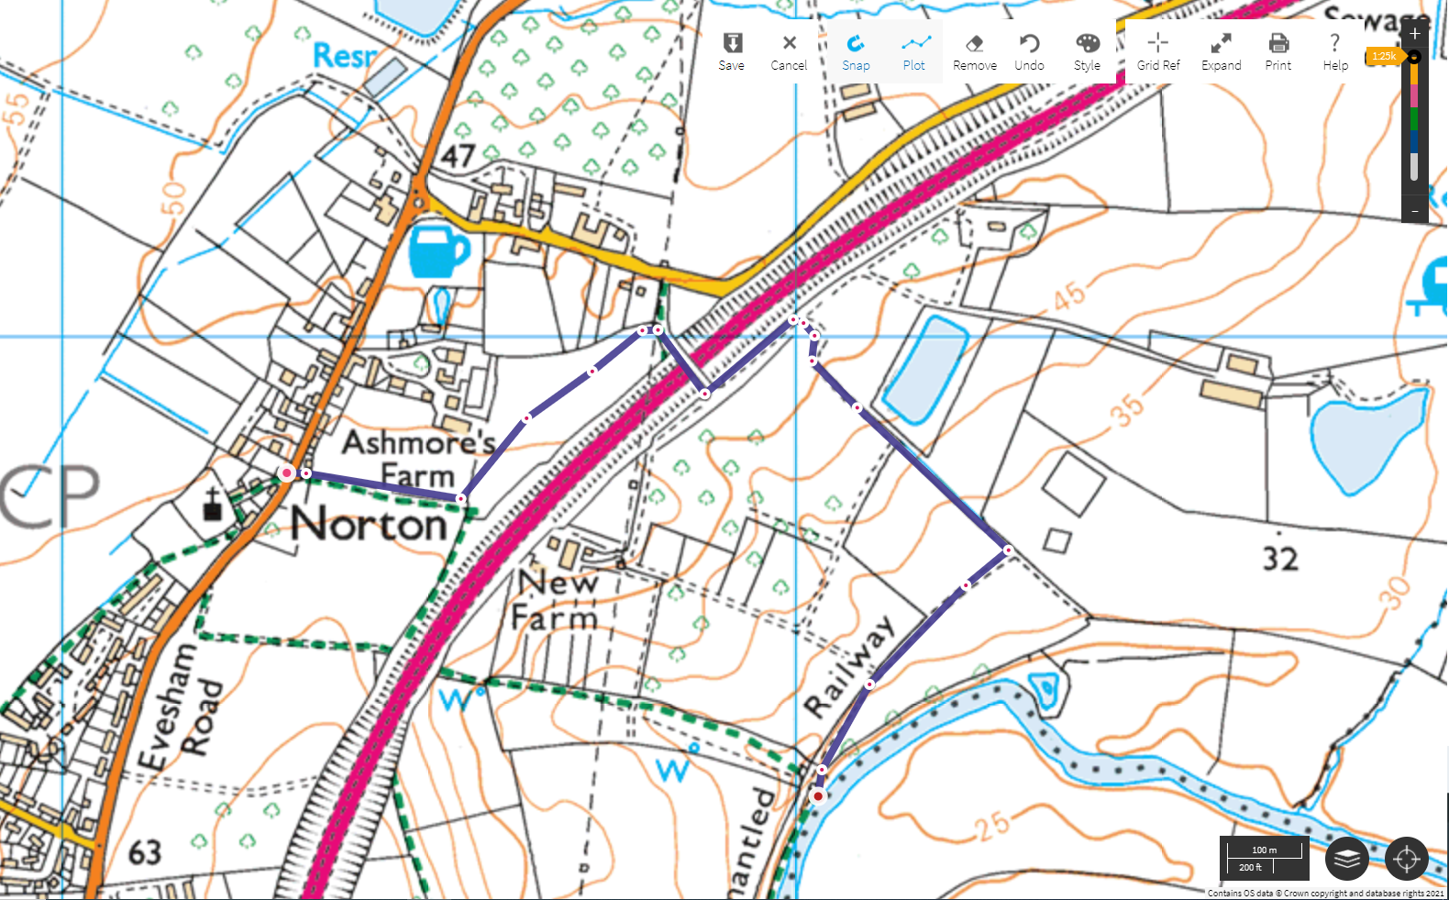
Down bank to rejoin RoW Footpath
Through small gate next to field gate
Through kissing gate, turn right over bridge
Through kissing gate, turn left

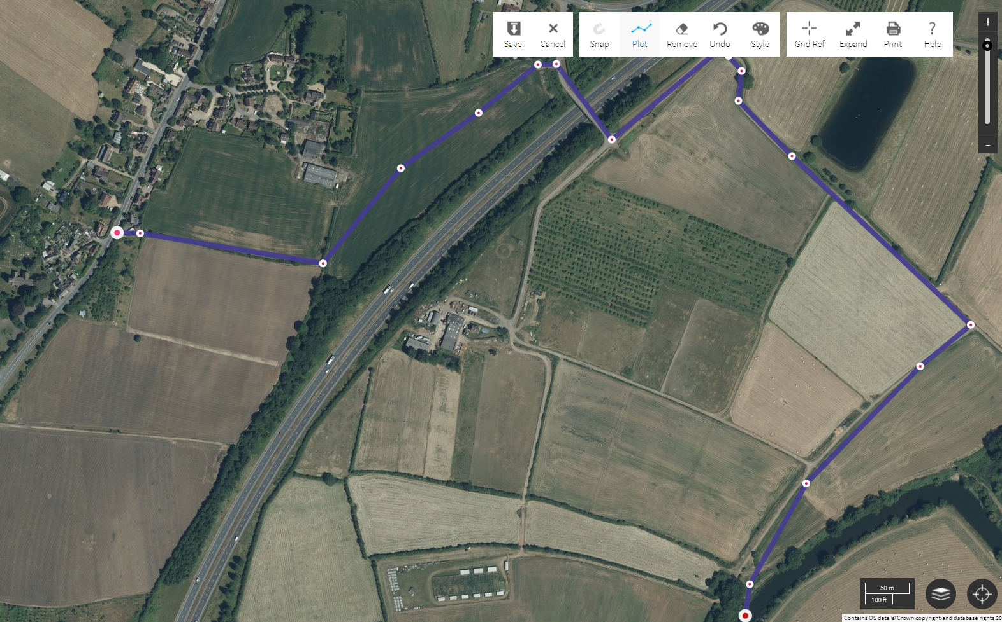
Down bank to rejoin RoW Footpath
Through small gate next to field gate
Through kissing gate, turn right over bridge
Through kissing gate, turn left

